 | Mandatory Disclosure | Updated on 5 April
10.1 | AICTE File No. | North-West/1-44643096085/2025/EOA
 | Date & Period of last approval | 5-April-2025 (2025-26)
10.2 | Name of the Institution | LALA LAJPAT RAI INSTITUTE OF ENGINEERING &TECHNOLOGY
 | Address of the Institution | FEROZPUR ROAD, NEAR PS SADAR, GHAL KALAN MOGA - 142001
 | City & Pin Code | Moga-142001
 | State / UT | Punjab
 | Longitude & Latitude | Longitude: 75⁰ 15’ 15” Latitude: 30⁰ 35’ 31” E
 | Phone number with STD  Code | (01636) 509968
 | FAX number with STD code
 | Office hours at the  Institution | From 0900 hrs to 1630 hrs
 | Academic hours at the  Institution | From 0900 hrs to 1630 hrs
 | Email | llriet@llriet.ac.in
 | Website | www.llriet.co.in
 | Nearest Railway Station(dist in | Ghal Kalan Distance in (Kms) : 5 Kms
 | Nearest Airport (dist in Km) | Amritsar Distance in (Kms) : 90 Kms
10.3 | Type of Institution | Private-Self Financed
Category (1) of the
Institution
 | Category (2) of the  Institution | Co-Ed
10.4 | Name of the organization running the institution | Shiva Educational Trust (Regd,)
 | Type of the organization | Self Financing (Minority)
 | Address of the  organization | Fauji Market Moga – 142001
 | Registered with | Registrar of Firms & Societies
 | Registration date | Chandigarh 3-6-1998
 | Website of the organization | www.llriet.co.in

10.5 | Name of the affiliating University | MAHARAJA RANJIT SINGH PUNJAB TECHNICAL UNIVERSITY
 | Address | Dabwali Road Bathinda (Punjab) 151001
 | Website | www.mrsstu.ac.in
 | Latest Affiliation | 19th July 2024
10.6 | Name of Principal / Director | Dr. Adarshpreet Mehta
 | Exact Designation | Principal
 | Phone number with STD  code | 01636 – 509968
 | FAX number with STD code
 | Email | dr.apmehta@llriet.ac.in
 | Highest Degree | Ph.D.
 | Field of specialization | HRM
10.7 | Governing Board Members | 1 Sh. Krishan Kumar Kaura Chairman  - Dr. Rohin Sachdeva Secretary  - Ms. Richa Sharma Member  - Sh. H.L.Sharma Member  - S. Ranjit singh Brar Member  - Sh. Vijay K. Gupta Member  - Ms. Baljinder Kaur Member  - Mr. Ajay Bansal Member  - Mr. Naresh Kumar Member  - The Nominee of the AICTE Member
10.7 | Governing Board Members | - An industrialist/ technologist/  Membe  rfrom the region to be nominated by the concerned Regional committeeas Nominee of the council  - The nominee of the University  Membe r(Maharaja Ranjit Singh Punjab Tech. University)

- The Nominee of State Govt
Membe
r(The Director, Tech Education & Industrial Training Pb.)

- An industrialist/ technologist/
Membe
rfrom the region to be nominated by the State Govt.
 | Frequency of meetings &  date of last meeting | Minimum three times in a year / 1st February 2025
10.8 | Academic Advisory Body | 1st January
 | Frequency of meetings & date of last meeting | Minimum three times in a year /10th February 2025

10. 9 Organizational Chart


Chairman
Principal
Dean
Head of Department
Registrar
Academics
R&D TPO
Sports
MCA
Bsc.IT
Accounts
Hostel warden
Student Welfare
Cultural
MBA
Applied Science
Administrative office
College development

10.10 | Institutional Governance  / faculty performance | Student feedback mechanism is already in place and it is used for corrective purposes
10.11 | Grievance redressal mechanism of faculty  , staff and students | College follows a proper hierarchical grievance redressal system. Students Depending on the type of their grievance can forward it to student counselor, Head of the department or the principal. Similarly faculty members can forward their grievances to the Head of the Department, the Principal or the Management.

10.12 Departments

Name of the Department | Department of Computer Application
Course | MCA/ BCA
Level (UG/PG) | PG/UG
1st Year of approval by the  Council | 2002
 | 2023-2024 | 2024-2025 | 2025-2026
Year wise Sanctioned Intake | 54/60 | 54/60 | 60/90
Year wise Actual Admissions | 38/53 | 39/60 | 57/90
Cut off marks – General quota
Students Placed
Average Pay package,
Rs./Year
Students opted for Higher
Studies
Accreditation Status of the course
Doctoral Courses
Foreign Collaborations, if any
Professional Society membership | ………………
Departmental activities | ……………...
Distinguished Alumni | ……………

FACULTY PROFILE

Name of Teaching Staff | ER.VISHAL MOHAN GOYAL |  | 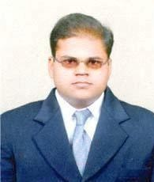
Designation | - DEAN ACADEMICS  - ASSISTANT PROFESSOR CUM HOD
Department | COMPUTERAPPLICATIONS
Date of Joining | JULY 16,2007
Qualification with Class/Grade | UG : BCA | PG : MCA  M.TECH (IT) | PhD: Pursuing
Total Experience (Years) | Teaching : 19 Years | Industry: - | Research: -
No. of Papers Published | National: 01 | International : -
Papers presented in Conference | National: 02 | International : -
PhD/Project Guided | PhDs : - | Projects at PG  Level01 |  | Projects at UG Level  -
Books published/IPR/Patents | Books : 02 | IPR  :- |  | Patents :-
Professional Memberships
Consultancy Activities
Awards
Grants fetched
Interaction with  Professional Institutions | - Presented UGC sponsored seminar at Arjan Daas College,Dharamkot.  - Presented UGC sponsored seminar at Sant Darbara SinghCollege, Lopon
Adhaar No. | 9780 0864 6734
E-mail address vishalmohan@llriet.ac.in

Name of Teaching Staff | Er. Anjali |  |  | 
Designation | Assistant Professor NSS Incharge
Department | Computer Applications
Date of Joining | 7 Nov 2016
Qualification with |  | UG : | PG : | PhD:
Class/Grade |  | B.Tech.(CSE) | M.Tech.(CSE)
Total Experience | Teaching :  9 Years |  | Industry: |  | Research:
(Years) |  |  | Industry: |  | 6 months
No. of Papers Published | National: 1 |  | International :1
Papers presented in | National: |  | International : 1
Conference
PhD/Project Guided | PhDs | : <Number> | Projects at PG Level |  | Projects at UG Level
PhD/Project Guided |  |  | <Number> |  | <Numer>
Books | Book  s | : <Number> | IPR |  | Patent s
published/IPR/Patent s | Book  s |  |  |  | Patent s
Professional
Memberships
Consultancy Activities
Awards
Grants fetched
Interaction with
professional Institutions
Adhaar No. | 379719330376
E-mail address | anjali@llriet.ac.in

Name of Teaching Staff | Ms. Jagroop Kaur |  | 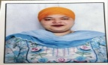
Designation | Assistant Professor
Department | COMPUTERAPPLICATIONS
Date of Joining | 17/07/2025
Qualification with Class/Grade | UG : BCA | PG : MCA | PhD:
Total Experience (Years) | Teaching : | Industry: - | Research: -
No. of Papers Published | National: | International : -
Papers presented in Conference | National: | International : -
PhD/Project Guided | PhDs : - | Projects at PG  Level01 |  | Projects at UG Level  -
Books published/IPR/Patents | Books : | IPR  :- |  | Patents :-
Professional Memberships
Consultancy Activities
Awards
Grants fetched
Interaction with

Professional Institutions
Adhaar No. | 220092544898
E-mail address balroop549@gmail.com

Name of Teaching Staff | Ms. Gania Goyal |  | 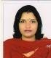
Designation | Assistant Professor
Department | COMPUTERAPPLICATIONS
Date of Joining
Qualification with Class/Grade | UG : BCA | PG :MCA | PhD:
Total Experience (Years) | Teaching : | Industry: - | Research: -
No. of Papers Published | National: | International : -
Papers presented in Conference | National: | International : -
PhD/Project Guided | PhDs : - | Projects at PG  Level01 |  | Projects at UG Level  -
Books published/IPR/Patents | Books : | IPR  :- |  | Patents :-
Professional Memberships
Consultancy Activities
Awards
Grants fetched
Interaction with

Professional Institutions
Adhaar No. | 415471731221
E-mail address ganiagoyal@llriet.ac.in

Name of Teaching Staff | Ms. Jasveen Kaur |  | 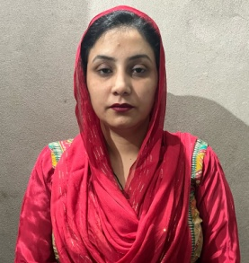
Designation | Assistant Professor
Department | COMPUTERAPPLICATIONS
Date of Joining | 15 April, 2025
Qualification with Class/Grade | UG : BCA | PG : MSC IT, MCA | PhD:
Total Experience (Years) | Teaching : | Industry: - | Research: -
No. of Papers Published | National: | International : -
Papers presented in Conference | National: | International : -
PhD/Project Guided | PhDs : - | Projects at PG Level 01 |  | Projects at UG Level  -
Books published/IPR/Patents | Books : | IPR :- |  | Patents :-
Professional Memberships
Consultancy Activities
Awards
Grants fetched
Interaction with

Professional Institutions
Adhaar No. | 431059779000
E-mail address jas.kaur3737@gmail.com

Name of Teaching Staff | Ms. Aashita Sood |  | 
Designation | Assistant Professor
Department | COMPUTERAPPLICATIONS
Date of Joining | 11 September 2023
Qualification with Class/Grade | UG : BCA | PG : MSC IT | PhD:
Total Experience (Years) | Teaching : | Industry: - | Research: -
No. of Papers Published | National: | International : -
Papers presented in Conference | National: | International : -
PhD/Project Guided | PhDs : - | Projects at PG Level 01: |  | Projects at UG Level:  -
Books published/IPR/Patents | Books : | IPR :- |  | Patents :-
Professional Memberships
Consultancy Activities
Awards
Grants fetched
Interaction with

Professional Institutions
Adhaar No. | 316120340962
E-mail address aashita@llriet.ac.in

Name of Teaching Staff | Ms. Jaswinder Kaur |  | 
Designation | Assistant Professor
Department | COMPUTERAPPLICATIONS
Date of Joining | 1 August 2025
Qualification with Class/Grade | UG : BCA | PG : | PhD:
Total Experience (Years) | Teaching : | Industry: - | Research: -
No. of Papers Published | National: | International : -
Papers presented in Conference | National: | International : -
PhD/Project Guided | PhDs : - | Projects at PG Level 01: |  | Projects at UG Level:  -
Books published/IPR/Patents | Books : 1 | IPR :- |  | Patents :-
Professional Memberships
Consultancy Activities
Awards
Grants fetched
Interaction with

Professional Institutions
Adhaar No. | 31924096312
E-mail address jaswinderkaurjossan322@gmail.com

Name of the Department | Department of Management
Course (B.Tech/M.Tech) | MBA/BBA/BCOM
Level (UG/PG) | PG/UG/UG
1st Year of approval by the Council | 2004
 | 2023-2024 | 2024-2025 | 2025-2026
Year wise Sanctioned Intake | 54/30/30 | 54/30/60 | 60/60/90
Year wise Actual Admissions | 42/19/27 | 54/30/60 | 60/60/90
Cut off marks – General quota | 55% | 55% | 55%
Students Placed
Average Pay package,
Rs./Year
Students opted for Higher
Studies
Accreditation Status of the course | --
Doctoral Courses | --
Foreign Collaborations, if any | --
Professional Society membership | …………………..
Departmental activities | ……………………
Distinguished Alumni | ……………………

FACULTY PROFILE
Name of Teaching Staff | Ms. SIMRANJEET KAUR |  |  | 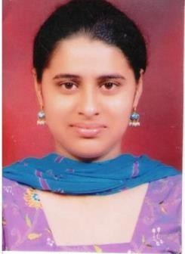
Designation | HOD & ASSISTANT PROFESSOR  CUM TPO
Department | MBA
Date of Joining | 11/08/2010
Qualification with | UG : BSC (NM)/48% |  | PG : MBA/ 73% | PhD:
Class/Grade |  |  | PG : MBA/ 73%
Total Experience | Teaching : 15 YEARS |  | Industry: | Research:
(Years) |  |  | Industry:
No. of Papers Published | National: |  | International :
Papers presented in | National: |  | International :
Conference
PhD/Project Guided | PhDs | : <Number> | Projects at PG Level |  | Projects at UG Level
PhD/Project Guided |  |  | <Number> |  | <Numer>
Books | Books | : <Number> | IPR |  | Patents
published/IPR/Patents |  |  |  |  | Patents
Professional
Memberships
Consultancy Activities
Awards
Grants fetched
Interaction with
professional Institutions
Adhaar No. | 9914440301287
E-mail address | simran@llriet.ac.in

Name of Teaching Staff | MS. RIMPY SHARMA |  | 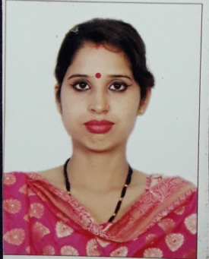
Designation | ASSISTANT PROFESSOR
Department | MBA/BBA/BCOM
Date of Joining | 1st may, 2024
Qualification with  Class/Grade | UG : BCA | PG: MBA : | PhD:
Total  Experience (Years) | Teaching : 6 years | Industry: - | Research: -
No. of Papers Published | National: | International : -
Papers presented inConference | National: | International : -
PhD/Project Guided | PhDs : - | Projects at PG  Level01 |  | Projects at UG Level  -
Books published/IPR/Patent  s | Books : | IPR  :- |  | Patents :-
Professional Membership
s
Consultancy Activities
Awards
Grants fetched
Interaction with

Professional Institutions
Adhaar No. | 507232685764
E-mail address rimpysharma@llriet.ac.in

Name of Teaching Staff | MS. RAVINDER KAUR |  | 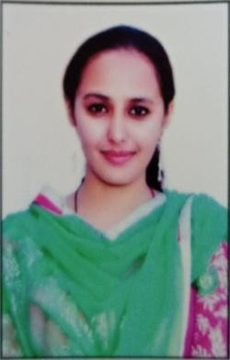
Designation | ASSISTANT PROFESSOR
Department | MBA/BBA/BCOM
Date of Joining | 14 FEB 2020
Qualification with Class/Grade | UG : BA(ARTS) | PG :  M B A ( H R & M R K T) | PhD:
Total Experience (Years) | Teaching : | Industry: - | Research: -
No. of Papers Published | National: | International : -
Papers presented in Conference | National: | International : -
PhD/Project Guided | PhDs : - | Projects at PG Level01 |  | Projects at UG Level  -
Books published/IPR/Patents | Books : | IPR :- |  | Patents :-
Professional Memberships
Consultancy Activities
Awards
Grants fetched
Interaction with

Professional Institutions
Adhaar No. | 548004474816
E-mail address ravinder@llriet.ac.in

Name of Teaching Staff | MS. JASMILAN KAUR |  | 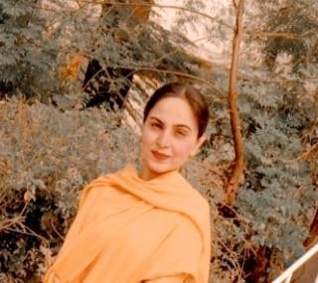
Designation | ASSISTANT PROFESSOR
Department | MBA/BBA/BCOM
Date of Joining | 6 MARCH 2023
Qualification with Class/Grade | UG : BCOM | PG : MCOM/M PHILL | PhD:
Total Experience (Years) | Teaching : | Industry: - | Research: -
No. of Papers Published | National: | International : -
Papers presented in Conference | National: | International : -
PhD/Project Guided | PhDs : - | Projects at PG Level 01 |  | Projects at UG Level  -
Books published/IPR/Patents | Books : | IPR :- |  | Patents :-
Professional Memberships
Consultancy Activities
Awards
Grants fetched
Interaction with

Professional Institutions
Adhaar No. | 461383934460
E-mail address jasmilan@llriet.ac.in

Name of Teaching Staff | Ms. Heena Rishi |  | 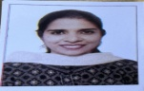
Designation | ASSISTANT PROFESSOR
Department | MBA/BBA/BCOM
Date of Joining | 16/07/2025
Qualification with Class/Grade | UG : BCOM | PG: MCOM, B.Ed | PhD:
Total Experience (Years) | Teaching : | Industry: - | Research: -
No. of Papers Published | National: | International : -
Papers presented in Conference | National: | International : -
PhD/Project Guided | PhDs : - | Projects at PG Level 01 |  | Projects at UG Level  -
Books published/IPR/Patents | Books : | IPR :- |  | Patents :-
Professional Memberships
Consultancy Activities
Awards
Grants fetched
Interaction with

Professional Institutions
Adhaar No. | 895555689960
E-mail address heenarishi13@gmail.com

Name of Teaching Staff | Ms. Varinder Kaur |  | 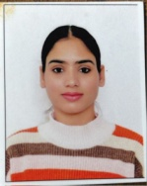
Designation | ASSISTANT PROFESSOR
Department | MBA/BBA/BCOM
Date of Joining | 04/08/2025
Qualification with Class/Grade | UG : BBA | PG : MBA | PhD:HR
Total Experience (Years) | Teaching : | Industry: -1 | Research: -3.5
No. of Papers Published | National:3 | International : -2
Papers presented in Conference | National:1 | International : -6
PhD/Project Guided | PhDs : - | Projects at PG Level 01 |  | Projects at UG Level  -
Books published/IPR/Patents | Books : | IPR :- |  | Patents :-
Professional Memberships
Consultancy Activities
Awards
Grants fetched
Interaction with

Professional Institutions
Adhaar No. | 809456307686
E-mail address varinderkaur0097@gmail.com

Name of Teaching Staff | DR. POOJA |  | 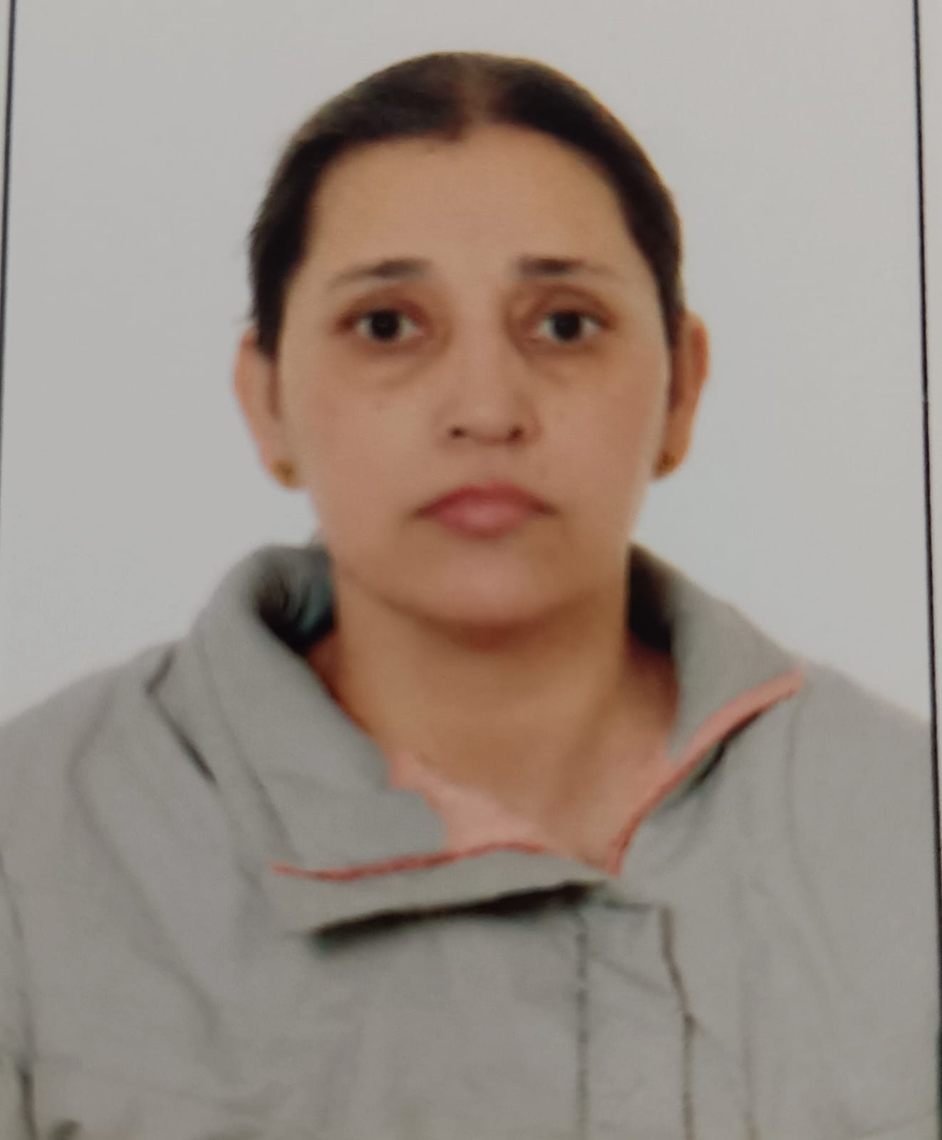
Designation | ASSISTANT PROFESSOR
Department | MBA/BBA/BCOM
Date of Joining | 12 August 2024
Qualification with Class/Grade | UG : BAMS | PG : MBA | PhD:
Total Experience (Years) | Teaching : | Industry: - | Research: -
No. of Papers Published | National: | International : -
Papers presented in Conference | National: | International : -
PhD/Project Guided | PhDs : - | Projects at PG  Level01 |  | Projects at UG Level  -
Books published/IPR/Patents | Books : | IPR  :- |  | Patents :-
Professional Memberships
Consultancy Activities
Awards
Grants fetched
Interaction with

Professional Institutions
Adhaar No. | 403798392331
E-mail address dr.pooja@llriet.ac.in
Name of Teaching Staff | Ms. HARJINDER |  | 
Designation | ASSISTANT PROFESSOR
Department | MBA/BBA/BCOM
Date of Joining | 13 aug 2024
Qualification with Class/Grade | UG :BCOM | PG : MCOM | PhD:
Total Experience (Years) | Teaching : | Industry: - | Research: -
No. of Papers Published | National: | International : -
Papers presented in Conference | National: | International : -
PhD/Project Guided | PhDs : - | Projects at PG  Level01 |  | Projects at UG Level  -
Books published/IPR/Patents | Books : | IPR  :- |  | Patents :-
Professional Memberships
Consultancy Activities
Awards
Grants fetched
Interaction with

Professional Institutions
Adhaar No. | 613284923414
E-mail address hkaurmba@llriet.ac.in

Name of Teaching Staff | MS. AARJU |  |  | 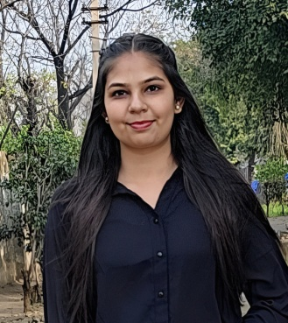
Designation | ASSISTANT PROFESSOR
Department | MBA/BBA/BCOM
Date of Joining | 14 oct, 2024
Qualification with Class/Grade | UG : BCOM | PG : MCOM |  | PhD:
Total Experience (Years) | Teaching : | Industry: - |  | Research: -
No. of Papers Published | National: | International : -
Papers presented in Conference | National: | International : -
PhD/Project Guided | PhDs : - | Projects at PG  Level01 |  |  |  | Projects at UG Level  -
Books published/IPR/Patents | Books : | IPR  :- |  |  |  | Patents :-
Professional Memberships
Consultancy Activities
Awards
Grants fetched
Interaction with

Professional Institutions
Adhaar No. | 416970773210
E-mail address aarju@llriet.ac.in
Name of Teaching Staff | MS. SHELLY |  |  | 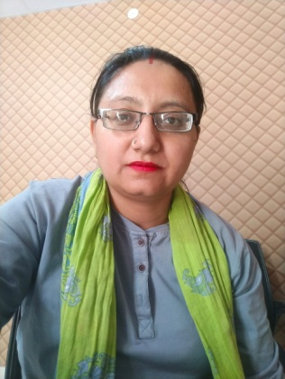
Designation | ASSISTANT PROFESSOR
Department | MBA/BBA/BCOM
Date of Joining | 10 Feb 2025
Qualification with Class/Grade | UG :BSC IT | PG : MBA(HR & FINANCE) |  | PhD:
Total Experience (Years) | Teaching : | Industry: - |  | Research: -
No. of Papers Published | National: | International : -
Papers presented in Conference | National: | International : -
PhD/Project Guided | PhDs : - | Projects at PG  Level01 |  |  |  | Projects at UG Level  -
Books published/IPR/Patents | Books : | IPR  :- |  |  |  | Patents :-
Professional Memberships
Consultancy Activities
Awards
Grants fetched
Interaction with

Professional Institutions
Adhaar No. | 462828672855
E-mail address shellypogla@gmail.com
Name of Teaching Staff | Mr. Jaswant Singh |  |  |  | 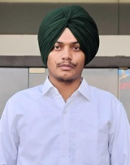
Designation | Assistant professor
Department | MBA/BBA/BCOM
Date of Joining | 01/07/2025
Qualification with Class/Grade | UG : BCOM (Hons.) |  | PG : MCOM (Hons.) |  | PhD:
Total Experience (Years) | Teaching : |  | Industry: - |  | Research: -
No. of Papers Published | National: |  | International : -
Papers presented in Conference | National: |  | International : -
PhD/Project Guided | PhDs : - |  | Projects at PG  Level01 |  |  |  | Projects at UG Level  -
Books published/IPR/Patents | Books : |  | IPR  :- |  |  |  | Patents :-
Professional Memberships
Consultancy Activities
Awards
Grants fetched
Interaction with

Professional Institutions
Adhaar No. | 651487643787
E-mail address js9728630@gmail.com

Name of the Department | Information Technology
Course | BSC IT/PGDCA
Level (UG/PG) | UG/PG
1st Year of approval by theCouncil | 2001
 | 2023-2024 | 2024-2025 | 2025-2026
Year wise Sanctioned Intake | 60 | 60/30 | 60/30
Year wise Actual Admissions | 45 | 60/21 | 60/30
Cut off marks – General quota | 55% | 55% | 55%
Students Placed
Average Pay package,Rs./Year
Students opted for HigherStudies
Accreditation Status of thecourse
Doctoral Courses
Foreign Collaborations, if any
Professional Society membership | ----------------
Departmental activities | Annexure II
Distinguished Alumni | -----------------

FACULTY PROFILE
Name of Teaching Staff | Gursharanjit Singh Cheema |  |  | 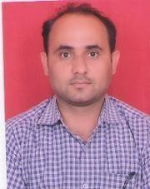
Designation | A.P. Cum HOD
Department | Info. Tech.
Date of Joining | 01/08/2006
Qualification with | B.Tech.(CSE) 1st Class  : |  | M.Tech.(IT),1st Class | P  h D:
Class/Grade |  |  | M.Tech.(IT),1st Class
Total Experience | Teaching: 14 Years |  | Industry: | Research:
(Years) |  |  | Industry:
No. of Papers Published | Natio nal: |  | International : 02
Papers presented in | Natio nal: |  | International :
Conference
PhD/Project Guided | PhDs | : <Number> | Projects at PG Level |  | Projects at UG Level
PhD/Project Guided |  |  | <Number> |  | <15>
Books | Book s | : <Number> | I P R |  | Patents
published/IPR/Pate nts | Book s |  |  |  | Patents
Professional
Memberships
Consultancy Activities
Awards
Grants fetched
Interaction with
professional Institutions
Adhaar No. | 437563954699
E-mail address | gursharanjitsingh@llriet.ac.in

Name of Teaching Staff | Gurtej Singh |  |  | 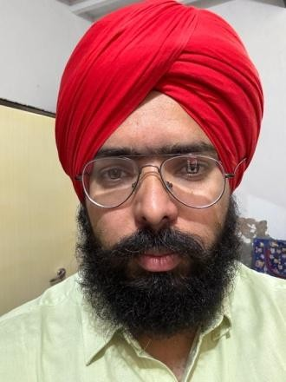
Designation | Assistant professor
Department | Information Technology
Date of Joining | 9/11/2016
Qualification with |  | UG : | PG : | PhD:
Class/Grade |  | B-Tech. IT | M-Tech C.S.E.
Total Experience |  | Teaching : | Industry: | Research:
(Years) |  | Years | Industry:
No. of Papers Published | National: |  | International : |  | 1
Papers presented in | National: |  | International :
Conference
PhD/Project Guided | PhDs | : <Number> | Projects at PG Level |  | Projects at UG Level
PhD/Project Guided |  |  | <Number> |  | <Number>
Books | Books | : <Number> | IPR |  | Patents
published/IPR/Patents |  |  |  |  | Patents
Professional
Memberships
Consultancy Activities
Awards
Grants fetched
Interaction with
professional Institutions
Adhaar No. | 468251331932
E-mail address | gurtejsingh@llriet.ac.in

Name of Teaching Staff | MS. SUKHMEET KAUR |  | 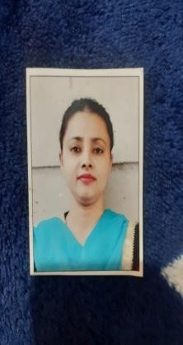
Designation | Assistant professor
Department | Information Technology
Date of Joining
Qualification with Class/Grade | UG : BTECH | PG :MTECH | PhD:
Total Experience (Years) | Teaching : | Industry: - | Research: -
No. of Papers Published | National: | International : -
Papers presented in Conference | National: | International : -
PhD/Project Guided | PhDs : - | Projects at PG  Level01 |  | Projects at UG Level  -
Books published/IPR/Patents | Books : | IPR  :- |  | Patents :-
Professional Memberships
Consultancy Activities
Awards
Grants fetched
Interaction with

Professional Institutions
Adhaar No. | 507339884581
E-mail address

Name of Teaching Staff | MS. NARINDER KAUR |  | 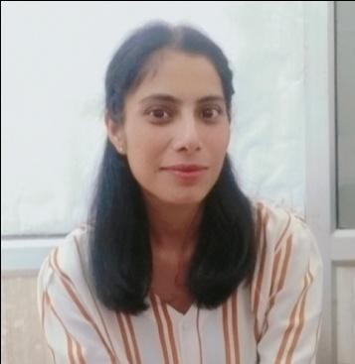
Designation | Assistant professor
Department | Information Technology
Date of Joining
Qualification with Class/Grade | UG : BA(CS) HONS | PG :  M.Sc IT | PhD:
Total Experience (Years) | Teaching : | Industry: - | Research: -
No. of Papers Published | National: | International : -
Papers presented in Conference | National: | International : -
PhD/Project Guided | PhDs : - | Projects at PG  Level01 |  | Projects at UG Level  -
Books published/IPR/Patents | Books : | IPR  :- |  | Patents :-
Professional Memberships
Consultancy Activities
Awards
Grants fetched
Interaction with

Professional Institutions
Adhaar No.
E-mail address

Name of Teaching Staff | MR. PUSHPINDER SINGH |  | 
Designation | Assistant professor
Department | Information Technology
Date of Joining | 01/01/2016
Qualification with Class/Grade | UG : BCA | PG :  M.Sc(IT) | PhD:
Total Experience (Years) | Teaching : | Industry: - | Research: -
No. of Papers Published | National: | International : -
Papers presented in Conference | National: | International : -
PhD/Project Guided | PhDs : - | Projects at PG  Level01 |  | Projects at UG Level  -
Books published/IPR/Patents | Books : | IPR  :- |  | Patents :-
Professional Memberships
Consultancy Activities
Awards
Grants fetched
Interaction with

Professional Institutions
Adhaar No. | 632117837739
E-mail address pushpinder@llriet.ac.in

Name of Teaching Staff | MS. HARPREET KAUR |  | 
Designation | Assistant professor
Department | Information Technology
Date of Joining | 24/03/2022
Qualification with Class/Grade | UG : BCA | PG :MCA | PhD:
Total Experience (Years) | Teaching : | Industry: - | Research: -
No. of Papers Published | National: | International : -
Papers presented in Conference | National: | International : -
PhD/Project Guided | PhDs : - | Projects at PG  Level01 |  | Projects at UG Level  -
Books published/IPR/Patents | Books : | IPR  :- |  | Patents :-
Professional Memberships
Consultancy Activities
Awards
Grants fetched
Interaction with

Professional Institutions
Adhaar No. | 941769445546
E-mail address hkaur@llriet.ac.in

Name of the Department | Applied Science
Course | BA
Level (UG/PG) | UG
1st Year of approval by theCouncil | 2001
 | 2025-2026
Year wise Sanctioned Intake | 60
Year wise Actual Admissions | 60
Cut off marks – General quota | 55%
Students Placed
Average Pay package,Rs./Year
Students opted for HigherStudies
Accreditation Status of thecourse
Doctoral Courses
Foreign Collaborations, if any
Professional Society membership | ----------------
Departmental activities | Annexure II
Distinguished Alumni | -----------------

DEPARTMENT OF APPLIED SCIENCES FACULTY PROFILE
Name of Teaching Staff | Tarish Mittal |  |  | 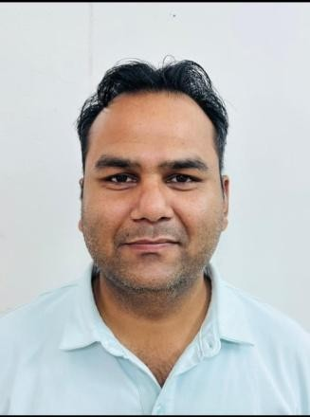
Designation | Assistant Professor
Department | Applied Science
Date of Joining | 16/7/2018
Qualification with |  | UG : | PG : M.Tech(ME) | PhD:
Class/Grade | B.Tech(ME) |  | PG : M.Tech(ME)
Total Experience |  | Teaching : | Industry: | Research:
(Years) |  | 1  1 | Industry:
No. of Papers Published | National: |  | International :
Papers presented in | National: |  | International :
Conference
PhD/Project Guided | PhDs | : <Number> | Projects at PG Level |  | Projects at UG Level
PhD/Project Guided |  |  | <Number> |  | <Numer>
Books | Books | : <Number> | IPR |  | Patents
published/IPR/Patents |  |  |  |  | Patents
Professional
Memberships
Consultancy Activities
Awards
Grants fetched
Interaction with
professional Institutions
Adhaar No. | 964072083976
E-mail address | tarishmittal@gmail.com

Name of Teaching Staff | Vijay Pal Garg |  |  | 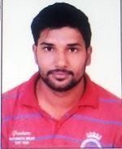
Designation | Assistant Professor
Department | Applied Science
Date of Joining | 1 August, 2019
Qualification with class/grade | Graduate in civil engineering: b.tech/1stclass |  | PG : M.Tech | PhD: 0
Total Experience | Teaching : 2  Year 5 Months |  | Industry: 2 Years | Research: 6 Months
(Years) |  |  | Industry: 2 Years
No. of Papers  Published | National: 0 |  | International : |  | 0
Papers presented in | National: 0 |  | International : 0
Conference
PhD/Project Guided | PhDs | : 0 | Projects at PG Level |  | Projects at UG Level
Books | Books | : 0 | 0 |  | Patents 0
published/IPR/Patents |  |  |  |  | Patents 0
Professional | Nil
Memberships
Consultancy Activities | 0
Awards | 0
Grants fetched | 0
Interaction with | 0
professional Institutions
Adhaar No. | 363251723541
E-mail address | vijaypal@llriet.ac.in

Name of Teaching Staff | MR. DELDEEP SINGH |  | 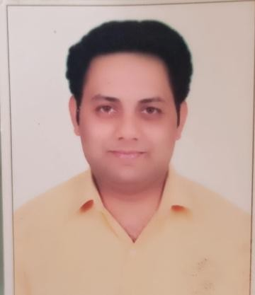
Designation | Assistant Professor
Department | Applied Science
Date of Joining | 2 MARCH 2023
Qualification with Class/Grade | UG : | PG :  MSC (MATHS) | PhD:
Total Experience (Years) | Teaching : | Industry: - | Research: -
No. of Papers Published | National: | International : -
Papers presented in Conference | National: | International : -
PhD/Project Guided | PhDs : - | Projects at PG  Level01 |  | Projects at UG Level  -
Books published/IPR/Patents | Books : | IPR  :- |  | Patents :-
Professional Memberships
Consultancy Activities
Awards
Grants fetched
Interaction with

Professional Institutions
Adhaar No. | 746305324883
E-mail address

Name of Teaching Staff | MR. SANJEEV KUMAR |  | 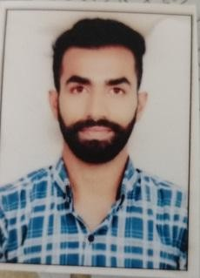
Designation | Assistant Professor
Department | Applied Science
Date of Joining | 09-05-22
Qualification with Class/Grade | UG : | PG :  M.A(eng.) | PhD:
Total Experience (Years) | Teaching : | Industry: - | Research: -
No. of Papers Published | National: | International : -
Papers presented in Conference | National: | International : -
PhD/Project Guided | PhDs : - | Projects at PG  Level01 |  | Projects at UG Level  -
Books published/IPR/Patents | Books : | IPR  :- |  | Patents :-
Professional Memberships
Consultancy Activities
Awards
Grants fetched
Interaction with

Professional Institutions
Adhaar No. | 433587254303
E-mail address sanjeev@llriet.ac.in

Name of Teaching Staff | Amritbir Singh |  |  | 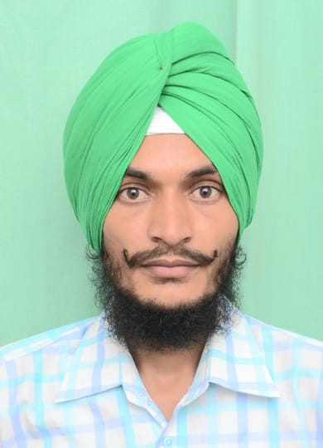
Designation | Assistant Professor
Department | Applied Science
Date of Joining | 16/11/2016
Qualification with |  | UG : | PG : M.Tech(ME) | PhD:
Class/Grade | B.Tech(ME) |  | PG : M.Tech(ME)
Total Experience | Teaching : 4 |  | Industry: | Research:
(Years) |  |  | Industry:
No. of Papers Published | National: |  | International :
Papers presented in | National: |  | International :
Conference
PhD/Project Guided | PhDs | : <Number> | Projects at PG Level |  | Projects at UG Level
PhD/Project Guided |  |  | <Number> |  | <Numer>
Books | Books | : <Number> | IP R |  | Patents
published/IPR/Patents |  |  |  |  | Patents
Professional
Memberships
Consultancy Activities
Awards
Grants fetched
Interaction with
professional Institutions
Adhaar No. | 546788137648
E-mail address | Maddar855@gmail.com

Name of Teaching Staff | Varinder Pal Singh |  | 
Designation | Assistant Professor
Department | Applied Science
Date of Joining | 01 January  2016
Qualification with Class/Grade | UG :  B.tech(CSE) | PG :  M.tech(CSE) | PhD:
Total Experience (Years) | Teaching : | Industry: - | Research: -
No. of Papers Published | National: | International : -
Papers presented in Conference | National: | International : -
PhD/Project Guided | PhDs : - | Projects at PG  Level01 |  | Projects at UG Level  -
Books published/IPR/Patents | Books : | IPR  :- |  | Patents :-
Professional Memberships
Consultancy Activities
Awards
Grants fetched
Interaction with

Professional Institutions
Adhaar No. | 807778754589
E-mail address

Name of Teaching Staff | Parminder Singh |  | 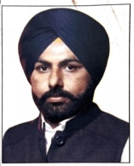
Designation | Assistant Professor
Department | Applied Science
Date of Joining | 1 August 2025
Qualification with Class/Grade | UG :  B.A (History, Pol. Sci) | PG :  M.A (Pol. Sci), MCA | PhD:
Total Experience (Years) | Teaching : | Industry: - | Research: -
No. of Papers Published | National: | International : -
Papers presented in Conference | National: | International : -
PhD/Project Guided | PhDs : - | Projects at PG  Level01 |  | Projects at UG Level  -
Books published/IPR/Patents | Books : | IPR  :- |  | Patents :-
Professional Memberships
Consultancy Activities
Awards
Grants fetched
Interaction with

Professional Institutions
Adhaar No. | 588781477074
E-mail address parmindergill193@gmail.com

Annexure II
Departmental Activities
Activity lists

S.No. | Activity Name | Description | Photograph
 |  | Group Discussion is a | 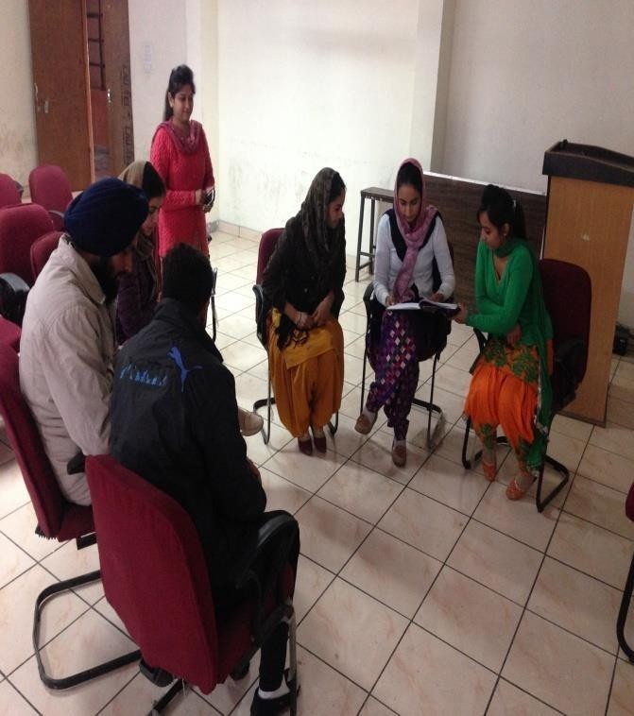
 |  | methodology or in a simple
 |  | language you may call it an
 |  | interview process or a group
 |  | activity. In this event the group
 |  | of candidates was given a topic
 | Group Discussion | or a situation, given a few minutes to think about the same,  and then asked to discuss the
1. |  | topic among themselves for 15-  20 minutes. Group Discussion
 |  | was conducted in the first week
 |  | of November 2025 in MBA
 |  | Deptt. by Ms. Simranjeet Kaur
 |  | Kaur on latest technologies in
 |  | business field. Final year Post
 |  | Graduated Students participated
 |  | in this event. They showed their
 |  | great interest.
2. | Poster Making | A poster is any piece of printed paper designed to be attached to a wall or vertical surface. Typically posters include both textual and graphic elements, although a poster may be either wholly graphical or wholly text.Posters are designed to be both eye-catching and informative.  Poster Making competition was held in the month of August 2025. It was conducted by Ms. Narinder Kaur. Many students participated in this  event. Students showed their talent and made beautiful posters. | 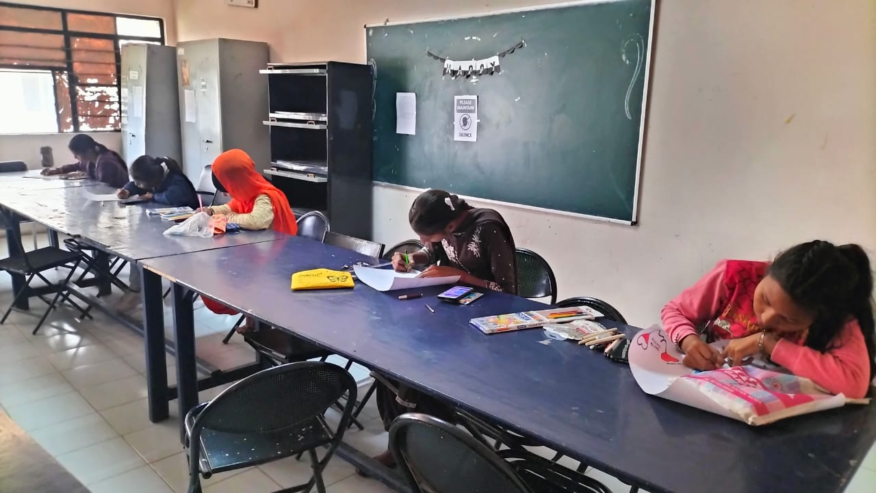

3. | Technical Quiz | A paper was conducted in this event which included Multiple Choice Questions were given. Many Students participated in this event. This was conducted by Mr. Gurtej Singh. Poster Making competition was held in the month of September 2025. | 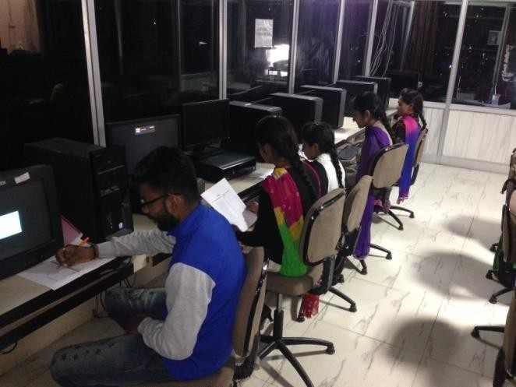

10.14 | Admission Quota# | Management Quota & State Quota
 | Entrance test / admissioncriteria
 | Cut off / last candidateadmitted
 | Fees in rupees | MCA | Rs. 25250 per  semester
 |  | MBA | Rs. 25250 per  semester
 | Number of Fee  Waiversoffered | 01
 | Admission Calendar | As announced by Maharaja Ranjit Singh Punjab Technical University, Bathinda
 | PIO quota | No
10.15 | Infrastructural Information | Campus
10.15 | Infrastructural Information | The college has a sprawling pollution free campus spread over 28 acres of land on the Moga, Ferozepur GT Road. The college has an ideal geographical location with the proximity to three important cities of the region i.e. Moga, Ludhiana and Ferozepur. The college is located at 9 km from Moga bus stand and 11 km from Moga Railway Station.
10.15 | Infrastructural Information | Buildings
10.15 | Infrastructural Information | The college has a number of beautiful and magnificent buildings in the form of Blocks. Block-1 houses Administrative wing and department of Computer Science and Engineering. In Block-II there are three departments namely ME, ECE and IT at different floors of the building. Block-III is called the Applied Sciences Department where all the classrooms and Laboratories for the first year classes are available. Block –IV is the PG Block where MBA/MCA and other PG classes are conducted. In this Block there are two Seminar rooms and one conference hall where there is a state of art multi media facility is used

Library

LLRIET,Moga has been centrally air-conditioned & well stocked library which is being continually upgrade and expands in terms of books, national & international journals. The library has extensive subject collections of more than 25000 books to support both recommended and background reading. Most of the books in the library can be easily accessed through open book system and borrowed for 15 days. Multiple copies of essential course text books are provided on the advice of tutors. The college has also got the institutional membership of DELNET. This facilitates students’ access to Delnet database through internet. The library also has a large number of instructional CDs. The library staff helps every student to ensure that he makes effective use of the library. The library subscribes to all important National newspapers, national & Inter-National journals, Business & computer magazines to update the students’ knowledge regarding current affairs, the state of economy & business. Institute has separate library for Post Graduate programs.
Workshops

Hands on laboratory experience, is important for the students. It complements & reinforces class-room presentation of course material. It also acquaints the students with modern equipment, process, procedures & design mythologies they will use after graduation. Following workshops are certainly a source of learning& creatvity.
- Machine Shop
- Foundry Shop
- Smithy Shop
- Fitting Shop
- Welding Shop
- Sheet Metal Shop
- Carpentry Shop
- Electrical Shop
Seminar Hall

The college can boast of well-designed and well-equipped air- conditioned seminar halls. These seminar halls serve as a platform for conducting various lectures/seminars of prominent personalities from industrial as well as academic background. The seminar halls are equipped with Multimedia LCD projector, high quality sound system, over head projector, computer and internet access.
Faculty & Staff Residences

Sufficient accommodation for the faculty as well as staff is available in the campus.

Guest House

A beautiful guest house with an estimated cost of Rupees Thirty five Lacs has been constructed recently.

Gymnasium/Sports Facilities

The separate Gymnasiums for boys and girls is a center of attraction for all the sports lovers of the Institution. The Gymnasium is equipped with latest exercise Machine of all sorts. It help in overall physical development of the students particularly hostellers.
Sports Stadium
To provide better sports facilities to the players and seating facility to the spectators to watch sports comfortably, stadium has been constructed. Sports Stadium has cost Rupees Forty Lacs.
Boys Hostels
The college has sufficient arrangement for residential students with three hostels for boys. Hostel, having capacity to accommodate 450 students.

10.16 | Classrooms/Tutorial Room faclities |  | 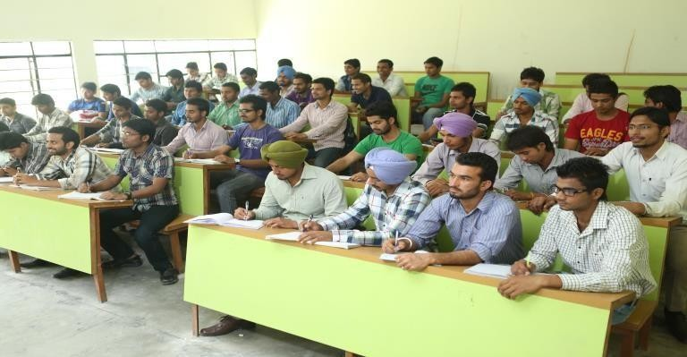  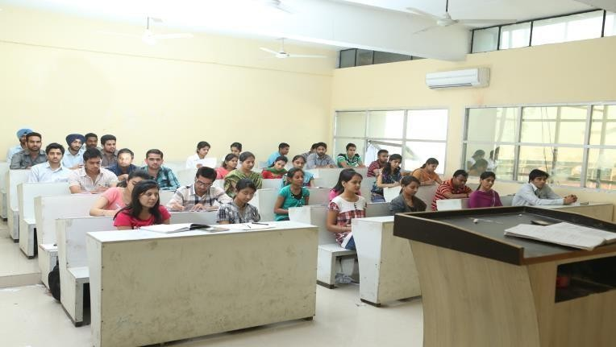  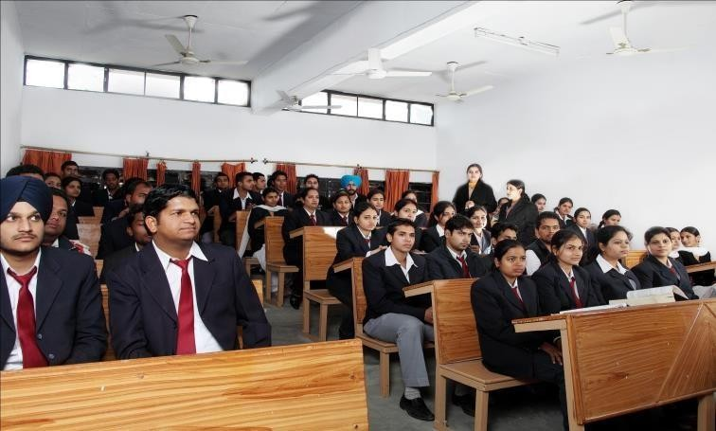

 | Computer centre facilities |  | 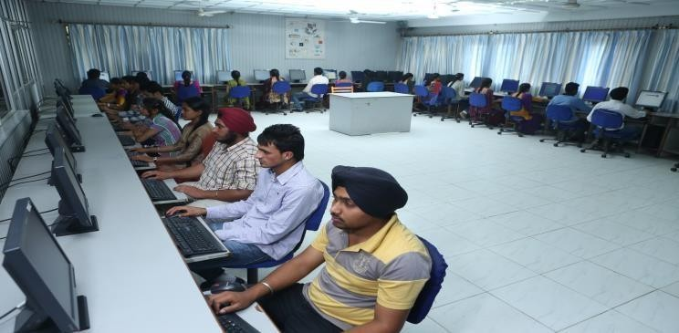  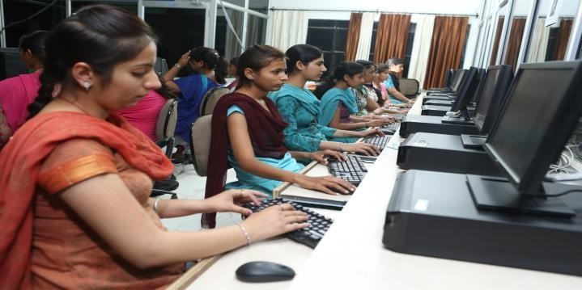
 | Library facilities |  | 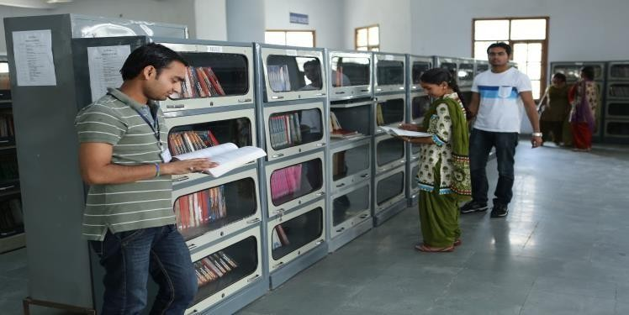  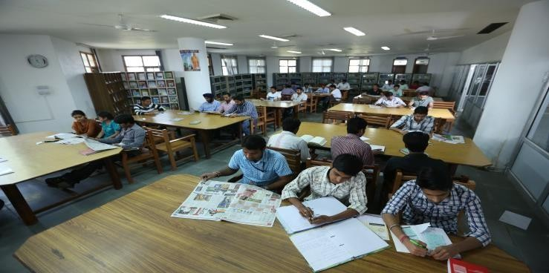

 | Auditorium/Seminar Halls |  | 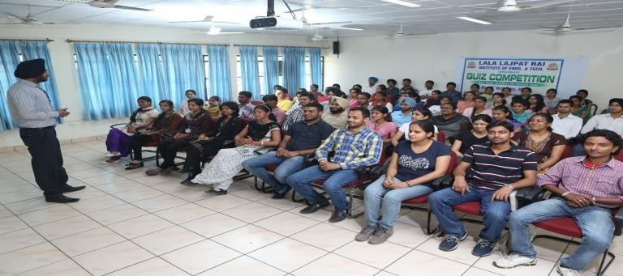  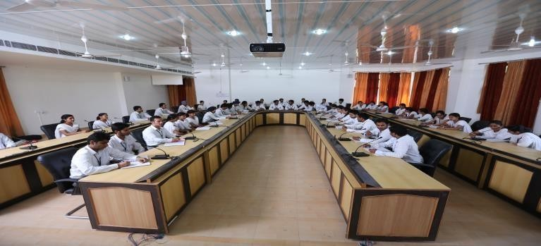  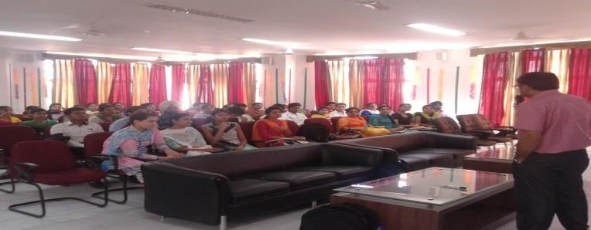
 | Cafeteria
 | Cafeteria |  | 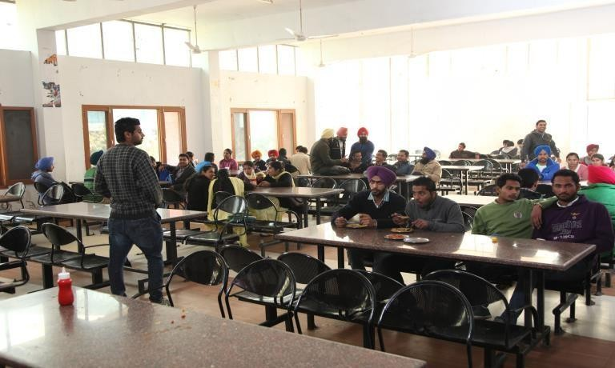

 | Indoor Sports facilities |  | 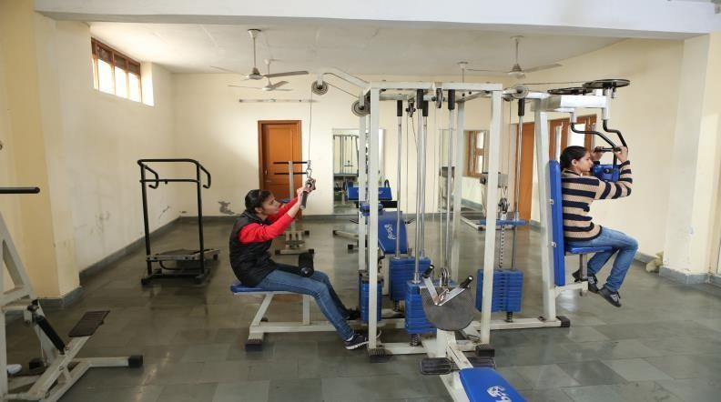
 | Outdoor Sports faclities |  | 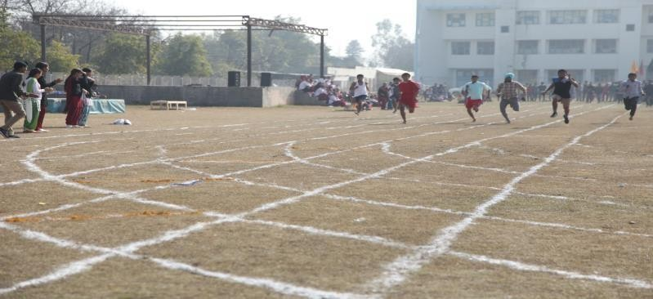

 | Gymnasium fcailities
 | Boys Hostel |  | 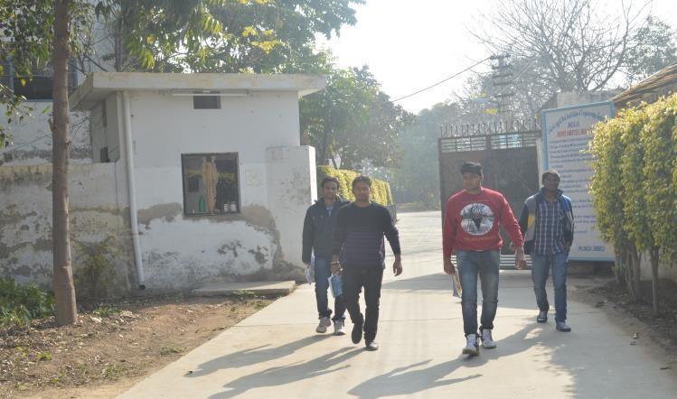  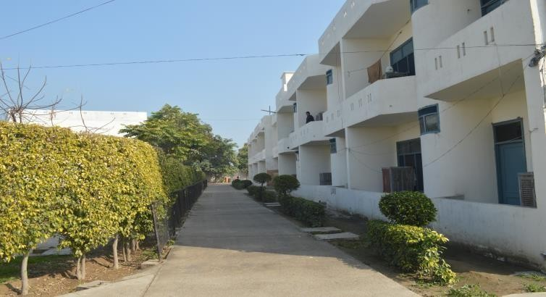

 | Girls Hostel |  | 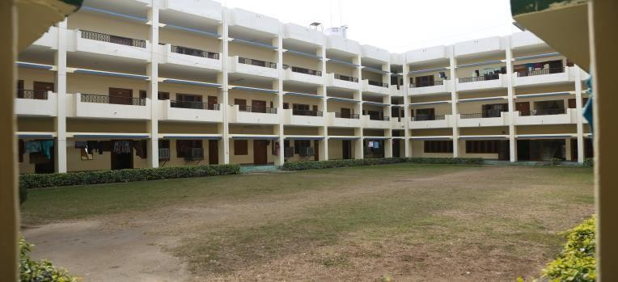
 | Medical facilities |  | 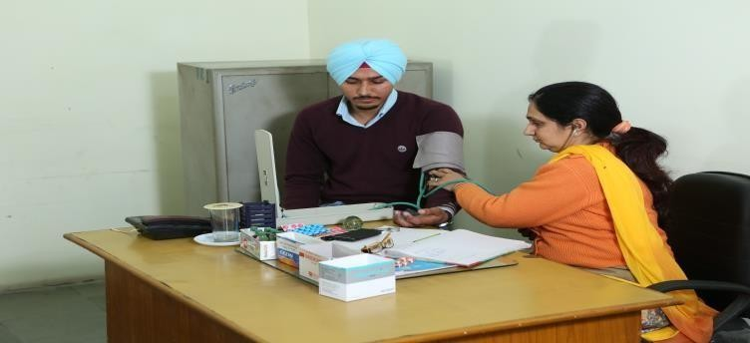  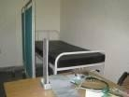

10.17 | Academic Sessions | 2025-26
 | Examination system, Year / Sem | Semester System
 | Period of declaration of results | Odd Semester : April  Even Semester : August
10.18 | Counseling / Mentoring | Available
 | Career Counseling | T & P Cell and Outside Experts
 | Medical facilities | Available
 | Student Insurance | Yes

10.19 | Student Activity Body | The N.S.S unit of the students is headed by Er Anjali. This unit organized  - Celebrated Independence day (14 august 2025) by conducting speech competition by the NSS unit of LLRIET, Moga.  - NSS unit organized Slogan Writing competition (4 Nov, 2025) on the topic of Blood donation.  - To celebrate World Aids Day, NSS unit organized Poster Making Competition on 5 Dec 2025 for students to aware them.  - To enlighten the students with Drug Awareness, again competition is organized by NSS on 27 Jan 2026.

 | Cultural activities | The cultural wing of the institute is being supervised by Mr. Gursharanjit Singh Cheema. Under this wing, The students remain active and dynamic throughout the year by organizing/Participating in various cultural programmes. This wing organized  - To celebrate the Teachers Day, event was organized on 9th September 2025 where students gave speech about the efforts of teachers and also reward them.  - Students participated in MRSPTU, Bathinda 10th Inter –Zonal Youth Festival “ Virsate Vikas” on 17th & 18th November 2025. Student of BCA participated in Solo dance and won 2nd position in festival.  - College also organized “AAGHAAZ Fresher Party 2025” which is held by LLRGOI campus on 22 Nov 2025to welcome the freshers with the blessings of almighty.  - On the occasion of Woman’s Day, LLRIET cultural team along with NSS unit celebrated the women empowerment with Female students by conducting various competitions like Dance, Mehndi, Speech & Poster making and also provide refreshments to them.
 | Sports activities | The Sports wing is being headed by Mr. Vijaypal Garg. This wing organized the following sport activities  - Annual Athletic Meet was held on 18th and 19th Feb 2025.  Students from different departments participated in various games. Varun Sharma student of Computer Applications won the best athlete award and Rajwinder kaur of Computer Applications achieve the Runner Up position.
 | Literary activities | The LLRIET information Brochure is published every year which highlights the academic achievements of the students, infrastructure provided, cultural, ISTE and NSS activities, Placements, and Industrial visits.
 | Magazine / Newsletter

